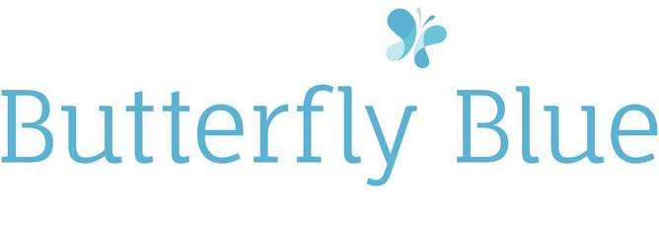
INTERVENTION REPORT
BACKGROUND
The Thrive Approach is a systematic approach to the early identification of emotional developmental needs in children and young people so that differentiated provision can be put in place.
The Approach is based in up to date neuroscience, attachment research, learning theory, child development studies and research into risk and resilience.
The Approach uses a developmental framework to clarify the connections between emotional and social development, behaviour and learning. A child’s development is explained through six strands of experience, each with accompanying tasks and opportunities. These translate into six fundamental aspects of learning for emotional and social development;
- Learning to be
- Learning to do
- Learning to think
- Learning to be powerful and have an identity
- Learning to be skilful and have structure
- Learning to be independent, relate to your peers and become secure in your sexual identity
As a child grows, each of these developmental strands will come online in sequence, although once in place, they are able to grow and change throughout life and are not fixed.
Changing circumstances throughout life can present both challenges and opportunities to learn or relearn until we have had ‘good enough’ experiences of being attuned, validated, contained and regulated by a responsive carer to then become competent at that strand of emotional development.
The Thrive Approach can help;
- Use some tried and tested ways to improve learning
- Increase attendance
- Improve learners’ emotional and social skills
- Improve relationships between peers and between learners and staff
- Produce evidence of progress in their emotional and social skills
- Improve and evidence your provision for vulnerable and challenging children
- Reduce staff stress

REPORT
The details enclosed are taken from shared information from key staff from your school, observations from Thrive sessions, observations of the child from their class teacher/TA as well as assessment using the Thrive Online tool.
All of the information has been anonymised in order for this to be shared with other agencies, and to protect the identity of the child.
The child in this report was assessed, and seen to have an interruption ta the first developmental strand of ‘Being’ (Learning to be safe, Learning to be special. Learning to have needs met). This is the stand that chronologically takes place from the final trimester to 6 months of age.
Gender and year group | Male, Year 4
Presentation before profiling: behaviours; relationships with adults/peers; incidents in class; incidents out of class; attendance; attainment | This child has completed a variety of tests to ascertain if he has any educational needs which require support. He has received a full complex needs assessment, ADHD/Autism assessment (negative) as well as an Educational and Clinical Psychology assessment. To date, he has received support in school in a group setting as part of the nurture provision as well as self-esteem group work and physical movement.  Behaviour displayed at school has been a happy enthusiastic child who is eager to please but finds it hard to settle to any task and frequently disrupts the whole class through shouting out, or stopping others working. He has low self-esteem around learning and refusing to take part in some activities such as writing, sharing ideas.  He has a small group of good friends and is liked by the other children though they find his disruptions annoying. Playtimes are enjoyable and occur without any incidents.  He interacts well with adults who he has developed a relationship with, otherwise he is quiet and does not give eye contact.  At home the family dynamic is complicated and chaotic and includes family breakdown and mental ill health for his primary care giver. The family have received ‘Team around the Child’ support as well as a ‘Team around the Family’.  At home he is often angry and breaks belongings and is not able to express or contain his feelings. His behaviour can become unmanageable and then is not managed at all.
Profile: stage of development and % scores: average % score and % score in 3 key task areas(eg in Being it would be % at Safety, % at Special % at Needs Met) | The assessment suggested working at the Being stage.  Scores of:  28% for Being Special  28% Having Needs Met  52% Being Safe.  The average score at the first assessment was 36%  (see Chart 1)
Examples of strategies and activities in action plan and number of sessions worked with pupil | The first Action Plan focused on learning target of  - Show that they feel they belong (Being Special)”  with a focus on building rapport and relationship with work on building eye contact, fun and physical closeness and feeling safe.  Activities included drawing/painting hands, sand tray, nature treasure hunt, free painting. All were focused on close proximity with the child receiving positive comments and praise.  The second Action Plan activities built upon the first but focused on the learning targets ;  - Can show you that they know you will listen to them (Being Special)  - Knows and can show or talk about the feelings in their body (Having Needs met)  - Can wait a little while to get attention (Having Needs met)  included making jewellery, eyes project and sensory awareness activities, as well as games such as balloon tennis  The third Action Plan activities focused on the learning targets of;  - Can tell someone (or signal) when scared or frightened (Having Needs Met)  - Can recognise different feelings in others and respond appropriately (Having Needs Met(  Activities included picture of body and where feelings are, practising calm activities for when you have to wait.  From July 2017- Dec 2017 this child has received 2 sessions of 30 minutes per week, scaling to one 30 minute session per week. To date 29 sessions have been completed (14.5 hrs contact time) with one practitioner.
Outcome of review of progress: stage and score % difference in areas as above | From the first to the third action plan, this child has progressed across all three areas within Being  AP 1= Being Safe 52%, Being Special 28% , Having Needs Met 28%  Average score: 36%  (see Chart 1)  AP 2= Being Safe 59%, Being Special 43%, Having Needs Met 30%  Average score: 44%  (see Chart 2)  AP 3= Being Safe 70%, Being Special 57%, Having Needs Met 41%  Average score: 56%  (see Chart 3)
What’s different? Eg behaviours; relationships with adults/peers; incidents in class; incidents out of class; attendance; attainment | Throughout the Thrive sessions, this young man has happily come along to every session with enthusiasm and curiosity.  He has followed all the rules and engaged in all of the activities.  He is warm, caring and has built eye contact, trust and rapport.  These traits have been taken back into the classroom, with him sharing willingly with his teachers and TA’s what he has been doing and shown work.  At the end of Y3 the class teacher recognised a more settled focused child, who checked in with her and the TA over any issues.  At the start of Y4 he became a little unsettled moving around in class a lot, however this is beginning to quieten down, with more work being completed and receiving praise and recognition from both the teacher and the Head for improvement in school work.  After a term in Y4, his new class teacher and TA have reported that this pupil is engaging more with their learning, receives positive comments well and knows how to seek help when needed.  Most recently he sat for 20 minutes for a visitors talk without disrupting himself or others and was fully immersed in what was being spoken about.  Although there have been continues family upheaval, he continues to engage with school and Thrive sessions and is developing a better understanding of his feelings and emotions and is expressing them with peers and adults in a more appropriate way.
Additional comments/reflections | This child has been able to move from a very low Being score of 36% to a final score of 56%  He has made strong attachments to key adults throughout the Thrive work, including the Practitioner and 2 TA’s across two different academic years. These attachments and learnt behaviours will be key for this child to feel safe and feel special at times of dysregulation or feelings of low self-worth.  Continuing to have ‘check-in’ points with key adults throughout the day will help to maintain, observe and allow this child to flourish.  Transitional objects have been key with this child, some have stayed within the classroom, while others have been taken home. Continuing to focus on these objects at times of stress/dysregulation will help him to focus on the feelings he is experiencing and make practised choices about what to do next. Having a key adult to ‘lend their brain’ at these times will also help to establish this as an imbedded behaviour and coping strategy.

CHART 1- Action Plan 1
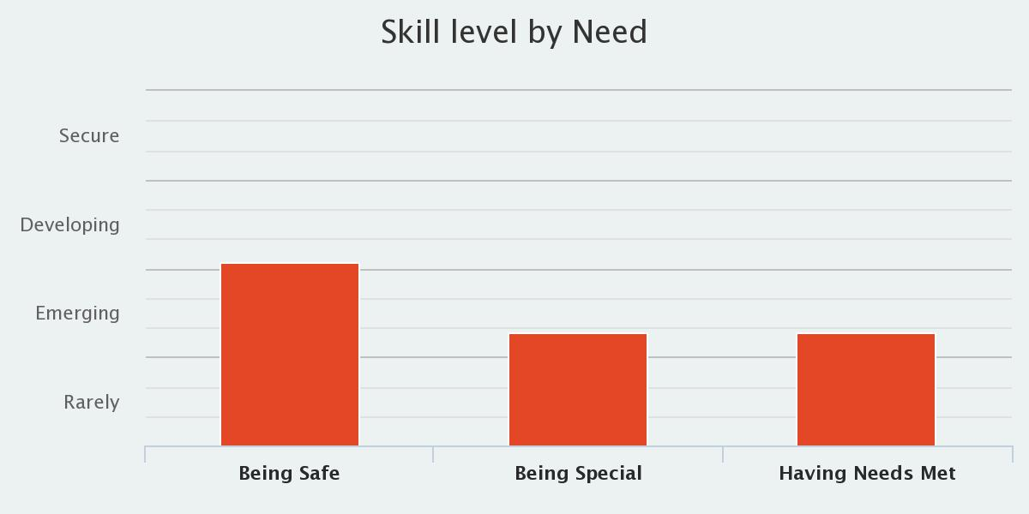
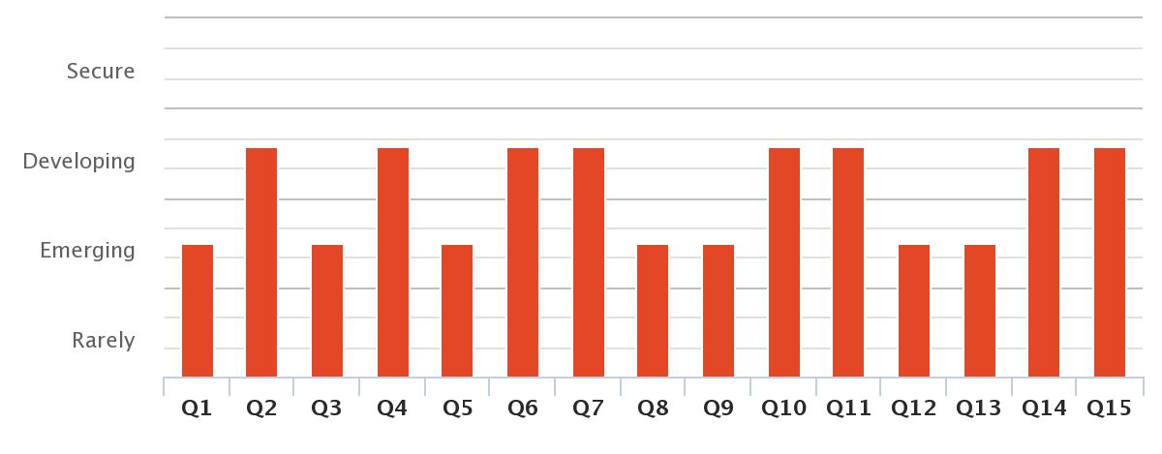
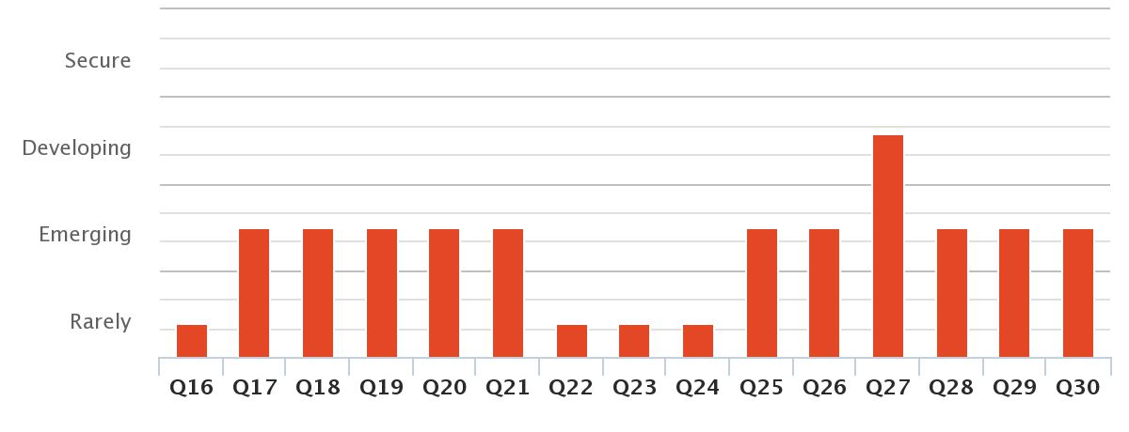
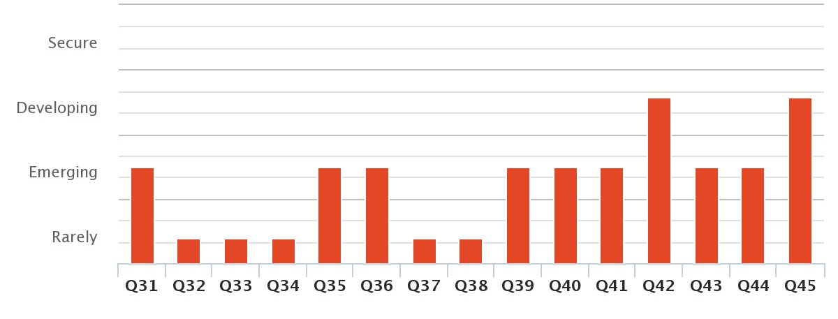

CHART 2- Action Plan 2
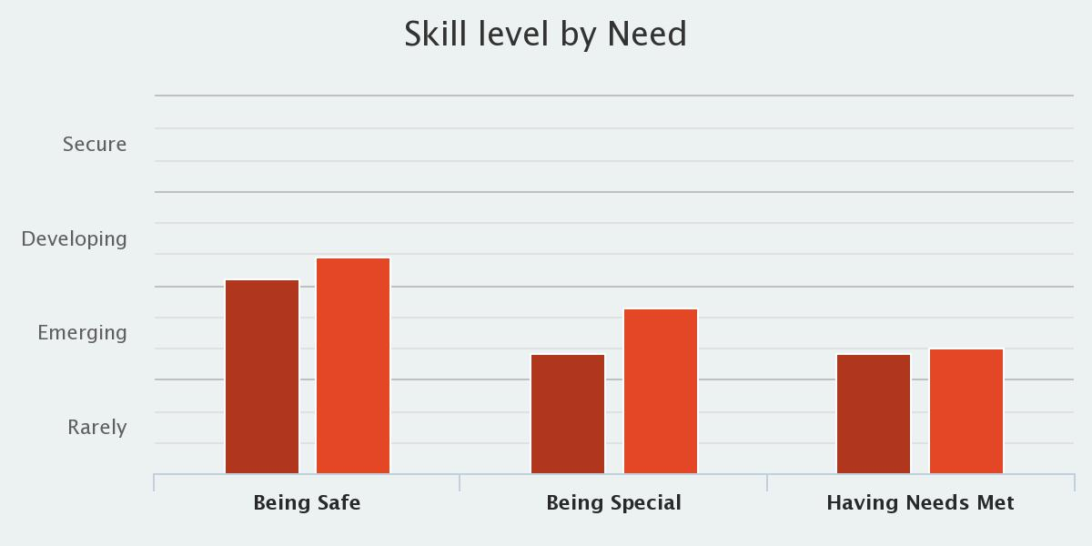

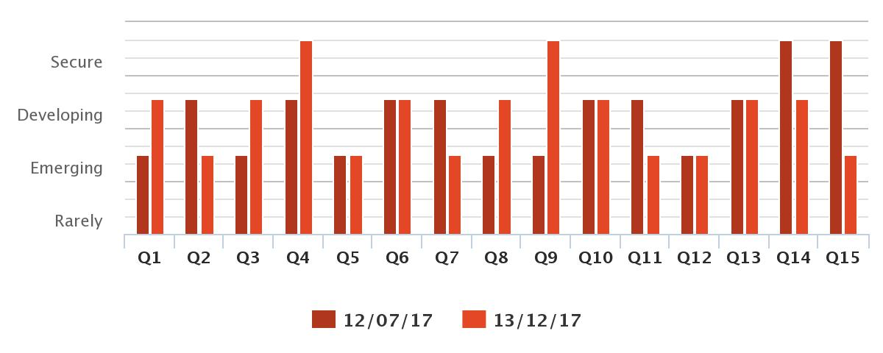

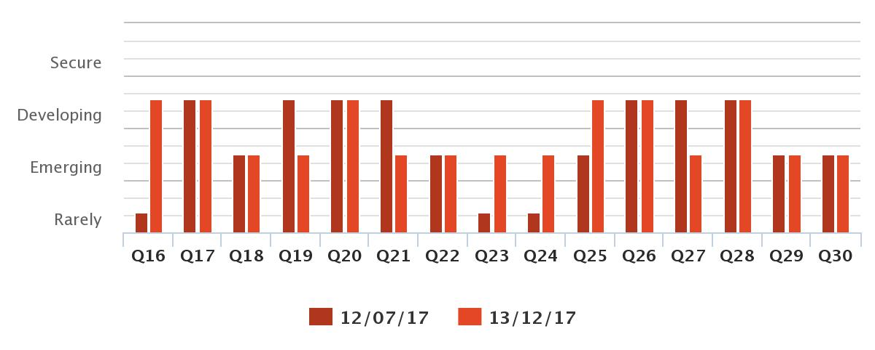

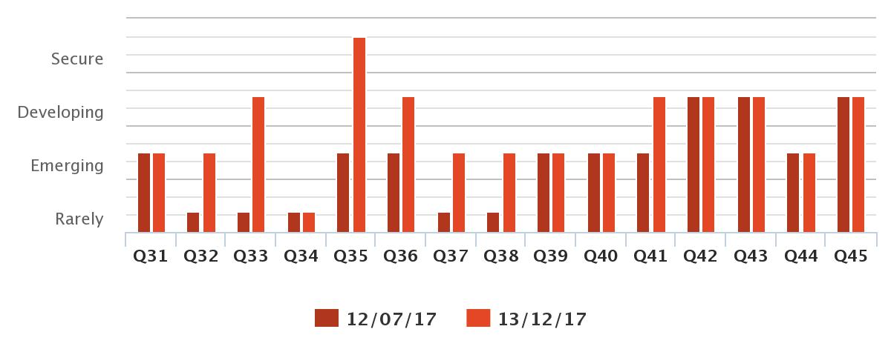
CHART 3- Action Plan 3
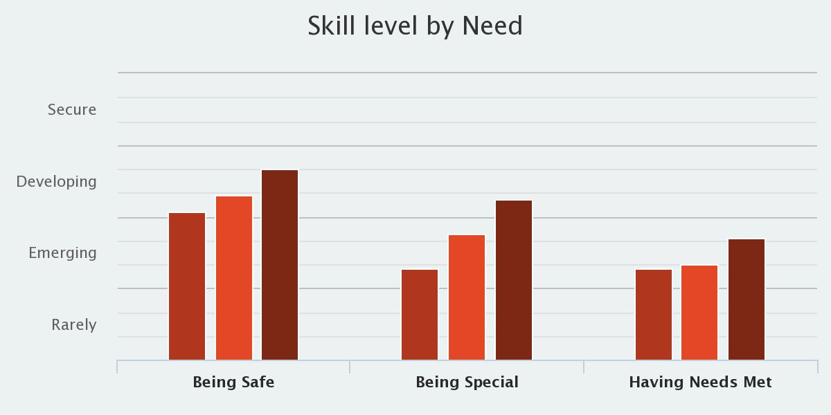
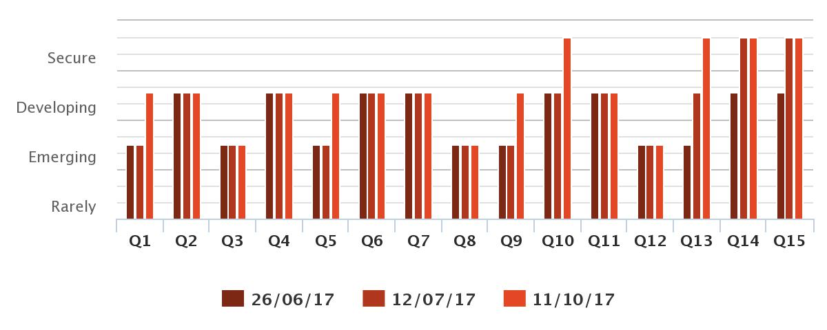

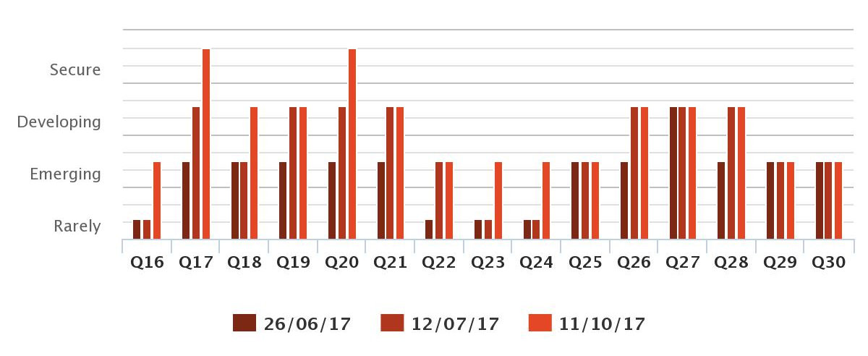
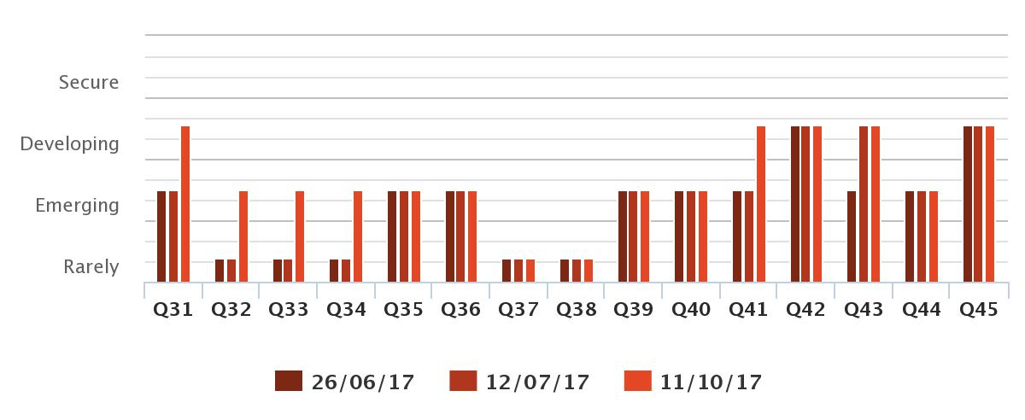

RECOMENDATIONS
This child will continue to need to focus at the developmental strand of ‘Being’ until he reaches the required ThriveOnline threshold of 64% which will then see him move onto tasks at ‘Doing’.
It is possible that this work can continue with non-Thrive Practitioner trained member of staff at the school. However, in order to track progress and measure impact and ensure that he is becoming competent at each strand of emotional development, it is advised to seek a trained Thrive Practitioner to complete Action Plans and to support staff.
It is also recommended that he receives a minimum of once a week (30 min) sessions with one key member of staff (so as to build a positive relationship with a significant adult). Once he has moved into ‘Doing’ it will be possible to consider if he is ready to move onto group sessions.

Recommended areas still needing focus:
The questions below are still highlighted to still be at a Rarely/Emerging level and therefore still require focus for this young person to continue to fill these interruptions at ‘Being.’
3. Be willing to work with a partner
8 Can signal or seek help when upset unhappy, angry or afraid
12. Is aware of/can signal when (s)he is not safe
25. Enjoys hearing or saying his/her name
29. Talks about himself/herself positively; says more than 1 thing
30. Takes part with ease in events when s/he is singled out briefly for praise or attention
35. Is willing to be helped
36. Is able to go to a safe place or person when needs to
37. Is empathetic and related well and appropriately to others
38. Knows and can signal when afraid
39. Knows and can signal when hot, cold, Hungry,, thirsty, uncomfortable, wet, tired, etc.
40. Recognises and signals when his/her body is uncomfortable or hurting
44. Signals when things are wrong

Additional Inclusions: All Action Plans are included as additional documents outside of this report.

